[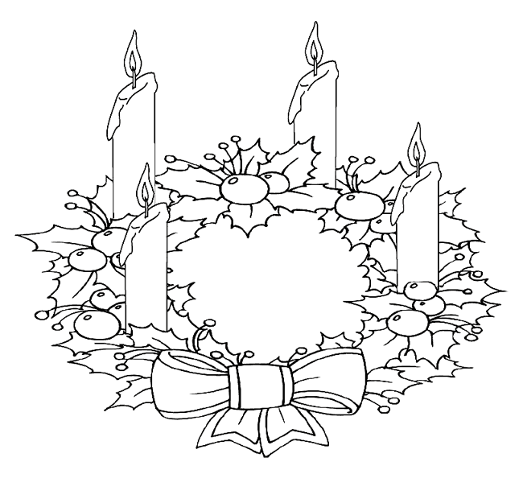](https://www.google.nl/url?sa=i&rct=j&q=&esrc=s&source=images&cd=&cad=rja&uact=8&ved=0ahUKEwjK4ryK9ojXAhXQEVAKHdgdBO8QjRwIBw&url=https://nl.pinterest.com/pin/392094711285978874/&psig=AOvVaw36sxeWxcKcCv6_6vQOFhGZ&ust=1508922601505352)